**MySQL – Day 1 – Task**

**Exercise 1 - Task:**

1. **Find the title of each film**

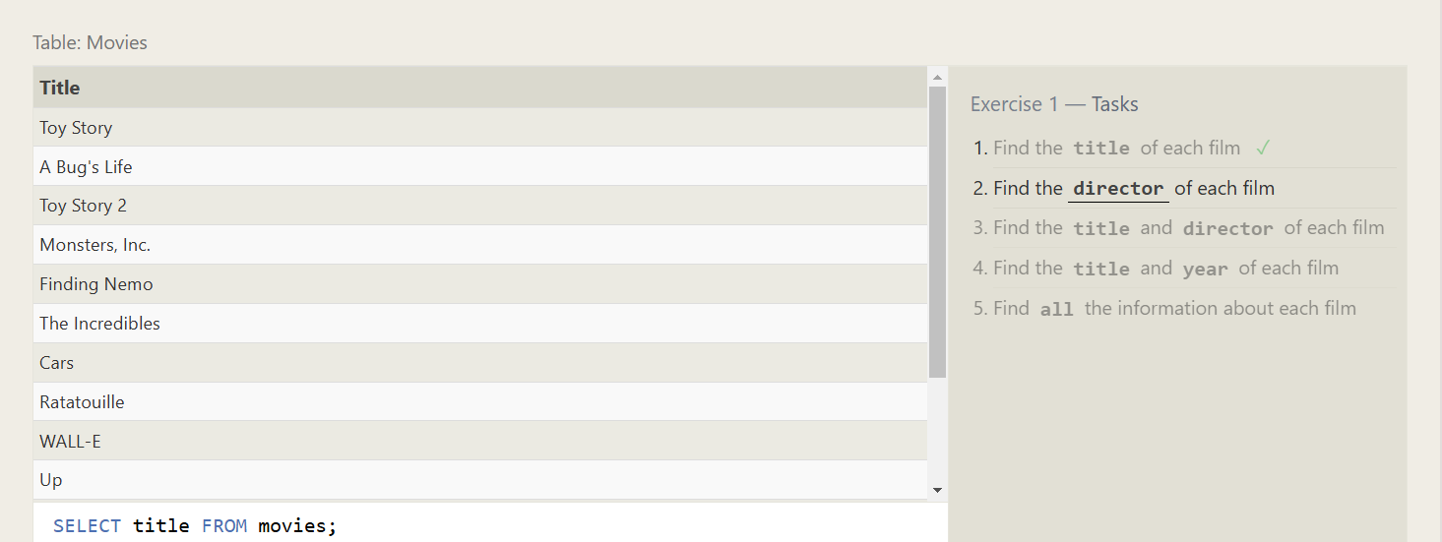

1. **Find the director of each film**

1. **Find the title and director of each film**

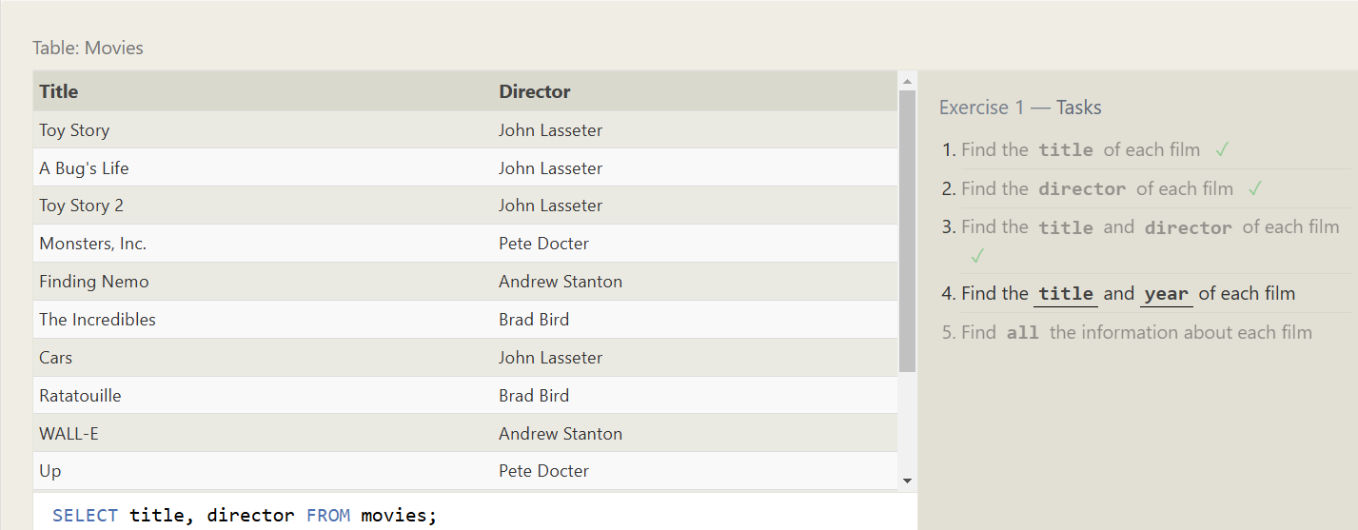

1. **Find the title and year of each film**

1. **Find all the information about each film**

**Exercise 2 - Task:**

1. **Find the movie with a row id of 6.**

1. **Find the movies released in the years between 2000 and 2010.**

1. **Find the movies not released in the years between 2000 and 2010.**

1. **Find the first 5 Pixar movies and their release year.**

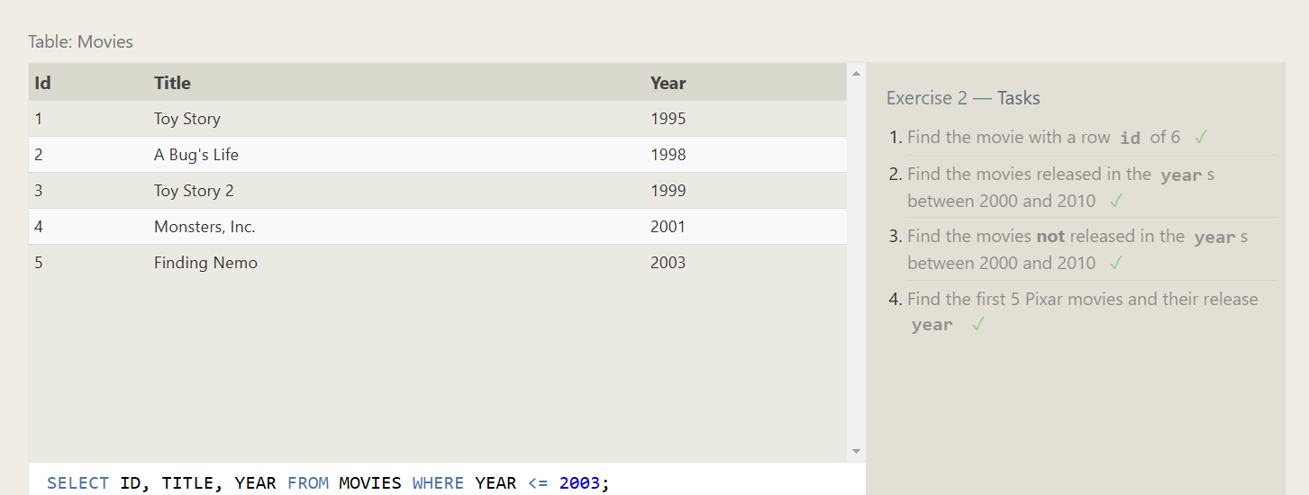

**Exercise 3 - Task:**

1. **Find all the Toy Story movies**

1. **Find all the movies directed by John Lasseter**

1. **Find all the movies (and director) not directed by John Lasseter**

1. **Find all the WALL-* movies**

**Exercise 4 - Task:**

1. **List all directors of Pixar movies (alphabetically), without duplicates**

1. **List the last four Pixar movies released (ordered from most recent to least)**

1. **List the first five Pixar movies sorted alphabetically.**

1. **List the next five Pixar movies sorted alphabetically**

**Exercise 5 - Task:**

1. **List all the Canadian cities and their populations.**

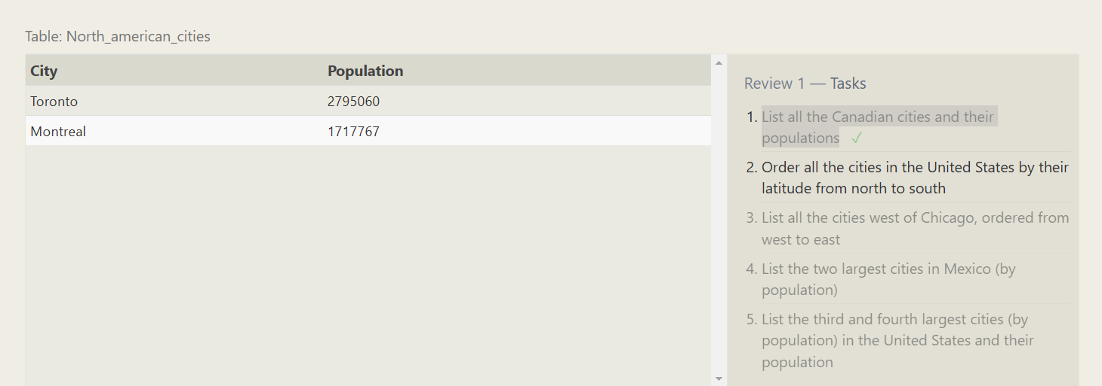

1. **Order all the cities in the United States by their latitude from north to south**

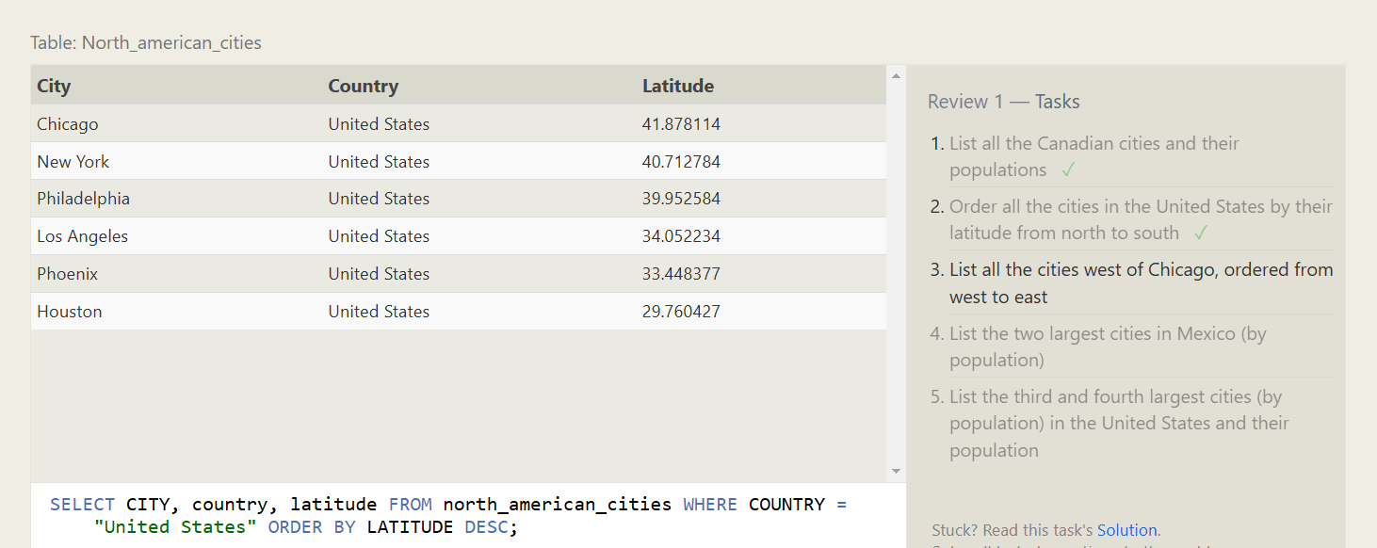

1. **List all the cities west of Chicago, ordered from west to east**

1. **List the two largest cities in Mexico (by population)**

1. **List the third and fourth largest cities (by population) in the United States and their population.**

**Exercise 6 - Task:**

1. **Find the domestic and international sales for each movie**

1. **Show the sales numbers for each movie that did better internationally rather than domestically**

1. **List all the movies by their ratings in descending order**

**Exercise 7 - Task:**

1. **Find the list of all buildings that have employees**

1. **Find the list of all buildings and their capacity**

1. **List all buildings and the distinct employee roles in each building (including empty buildings)**

**Exercise 8 - Task:**

1. **Find the name and role of all employees who have not been assigned to a building**

1. **Find the names of the buildings that hold no employees**

**Exercise 9 - Task:**

1. **List all movies and their combined sales in millions of dollars**

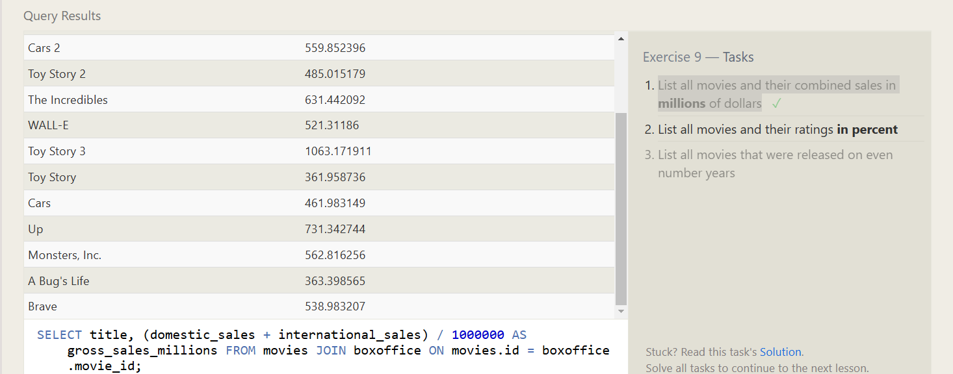

1. **List all movies and their ratings in percent**

1. **List all movies that were released on even number years**

**Exercise 10 - Task:**

1. **Find the longest time that an employee has been at the studio**

1. **For each role, find the average number of years employed by employees in that role**

1. **Find the total number of employee years worked in each building**

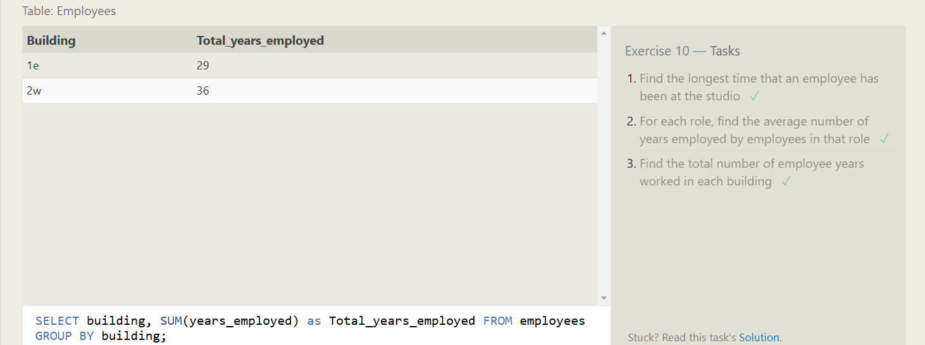

**Exercise 11 - Task:**

1. **Find the number of Artists in the studio (without a**HAVING**clause)**

1. **Find the number of Employees of each role in the studio**

1. **Find the total number of years employed by all Engineers**

**Exercise 12 - Task:**

1. **Find the number of movies each director has directed**

1. **Find the total domestic and international sales that can be attributed to each director**

**Exercise 13 - Task:**

1. **Add the studio's new production,**Toy Story 4**to the list of movies (you can use any director)**

1. **Toy Story 4 has been released to critical acclaim! It had a rating of**8.7**, and made**340 million domestically**and**270 million internationally**. Add the record to the**BoxOffice**table.**

**Exercise 14 - Task:**

1. **The director for A Bug's Life is incorrect, it was actually directed by John Lasseter**

1. **The year that Toy Story 2 was released is incorrect, it was actually released in 1999**

1. **Both the title and director for Toy Story 8 is incorrect! The title should be "Toy Story 3" and it was directed by Lee Unkrich**

**Exercise 15 - Task:**

1. **This database is getting too big, lets remove all movies that were released before 2005.**

1. **Andrew Stanton has also left the studio, so please remove all movies directed by him.**

**Exercise 16 - Task:**

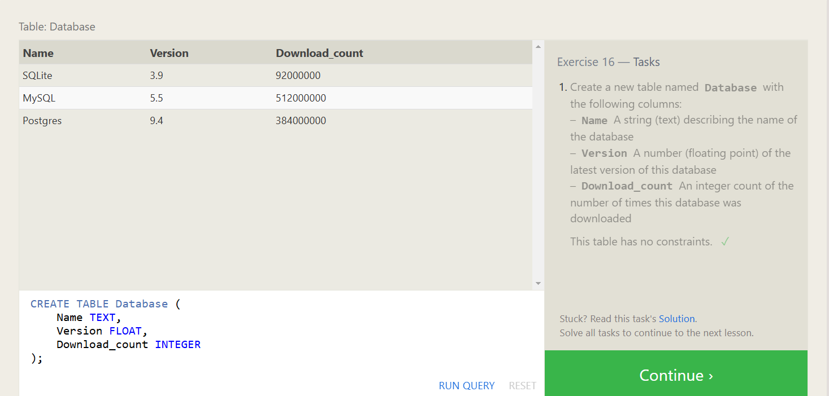

**Exercise 17 - Task:**

1. **Add a column named Aspect_ratio with a FLOAT data type to store the aspect-ratio each movie was released in.**

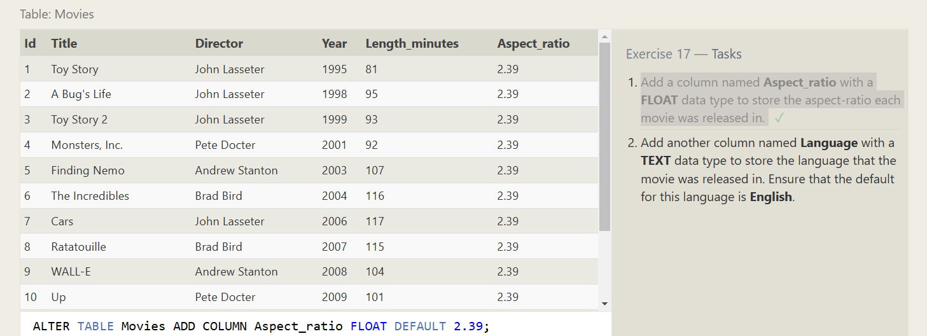

1. **Add another column named Language with a TEXT data type to store the language that the movie was released in. Ensure that the default for this language is English.**

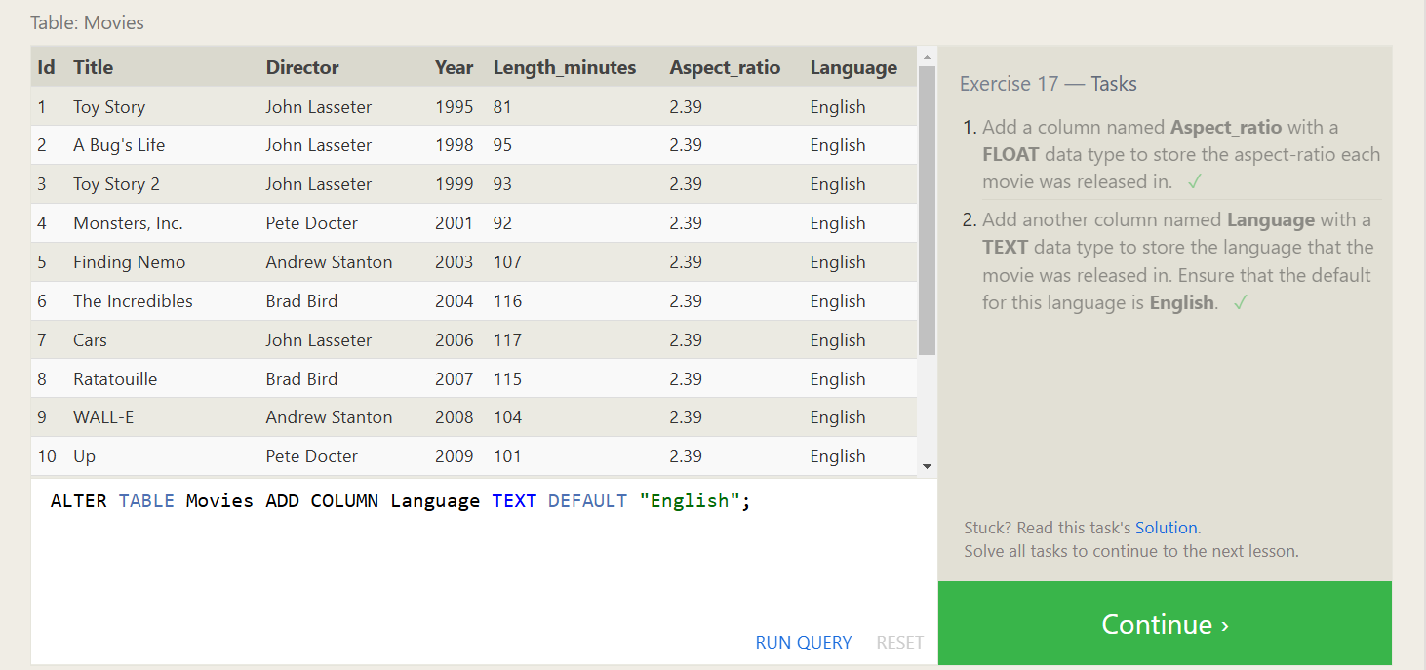

**Exercise 18 - Task:**

1. **We've sadly reached the end of our lessons, lets clean up by removing the Movies table**

1. **And drop the BoxOffice table as well**

***The End***